The concept of lexical scoping allows us to answer questions about what definition any reference to a name refers to.

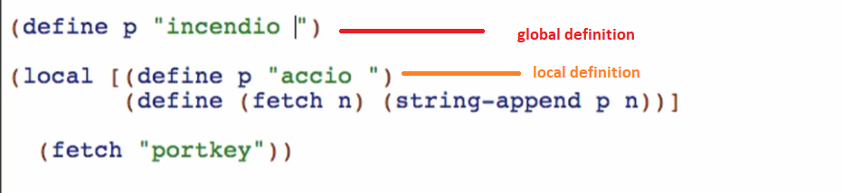

Running the code will produce: 

This concept is called lexical scoping.

Global/Top level scope:

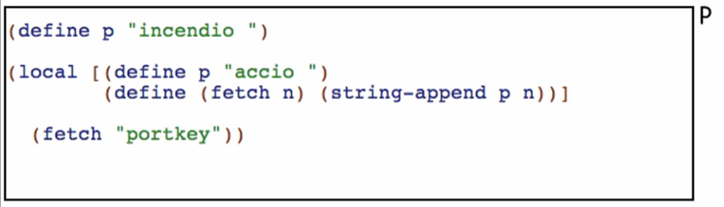

* For this code, we have a defined “p”

Local scope:

* Whenever we encounter a local, every definition gets set up in that box!

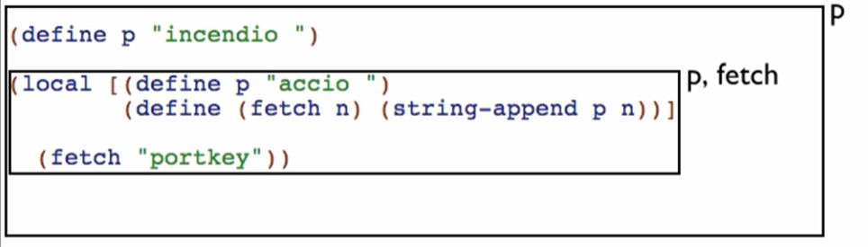

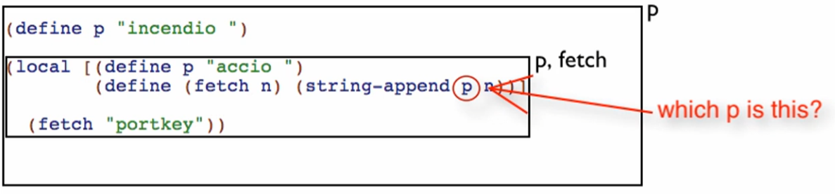

1. We start at that reference
2. Then we go to the innermost enclosing box

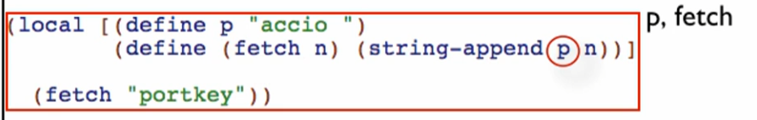

1. We check if that innermost enclosing box has defined “p” (reference)

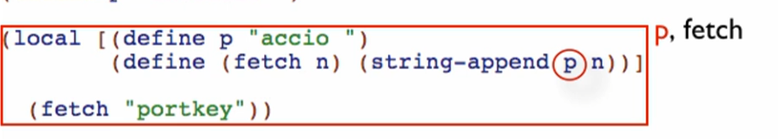

1. If the reference is defined in that local, we use that “p”!

Example for not founding the reference immediately on the innermost enclosing scope

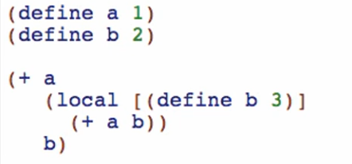

Scope:

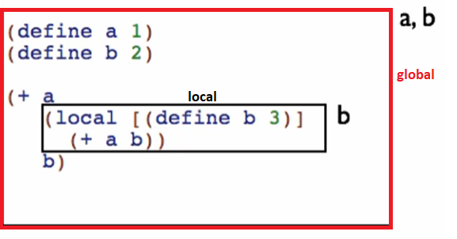

Let’s start with reference “a” and go to the nearest enclosing box:

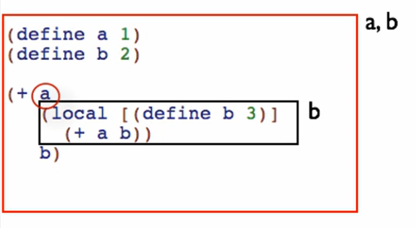

So this a would be 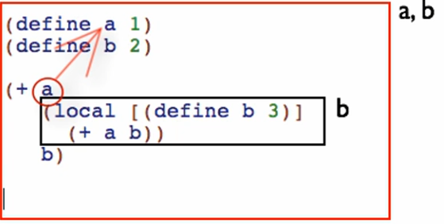

Let’s try the next reference “a” and go to the nearest enclosing box:

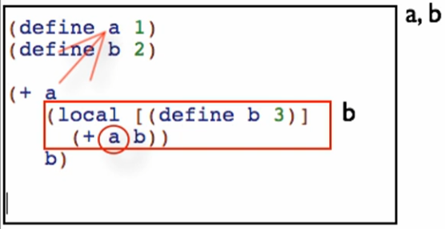

Does it define an “a”?

1. No, so we proceed to the next nearest enclosing box:

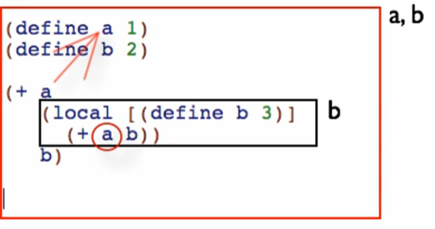

Does it define an “a”?

1. Yes, so we use that definition for that reference “a”

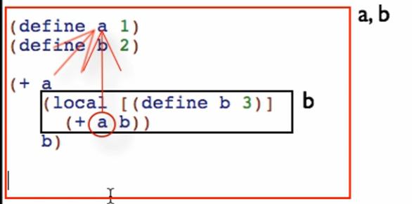

Let’s try reference “b” here and go to the nearest enclosing box

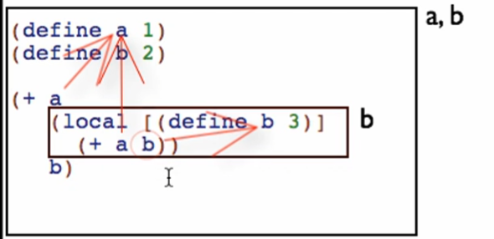

* It’s defined here so it is the definition of b!

Let’s try the last “b” and go to the nearest ENCLOSING box

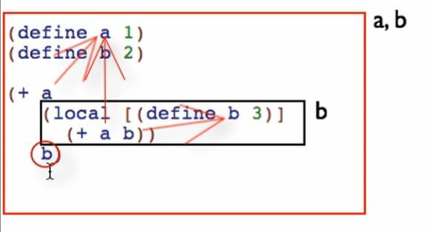

* This b is in global scope!

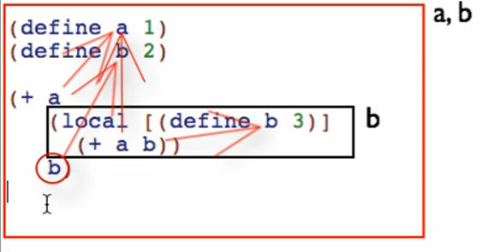

Expected value: 7

Run:  correct!

Checking the scope and reference in Dr Racket:

1. Click 
2. Hover over a reference:

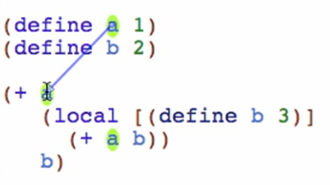

It will draw a line from the corresponding definition

1. Hover over a definition:

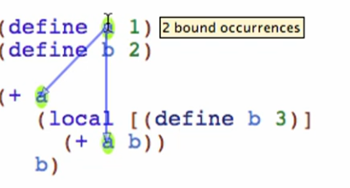

It will draw a line to all the corresponding references

Note: we can reference a definition inside a definition within the same local

